AI Assisted Coding End Lab Exam 20.11.2025 CSB01 and CSB02
📘 SET 1
Q1. Prompt Engineering (Scenario)
Your company is building an invoice summarizer. You must write a prompt that instructs AI to generate a Python function that extracts total amount, tax, and invoice number from a text paragraph. Refine the prompt until extraction accuracy improves.
(Include docstrings, comments, and test cases for the extracted function.)
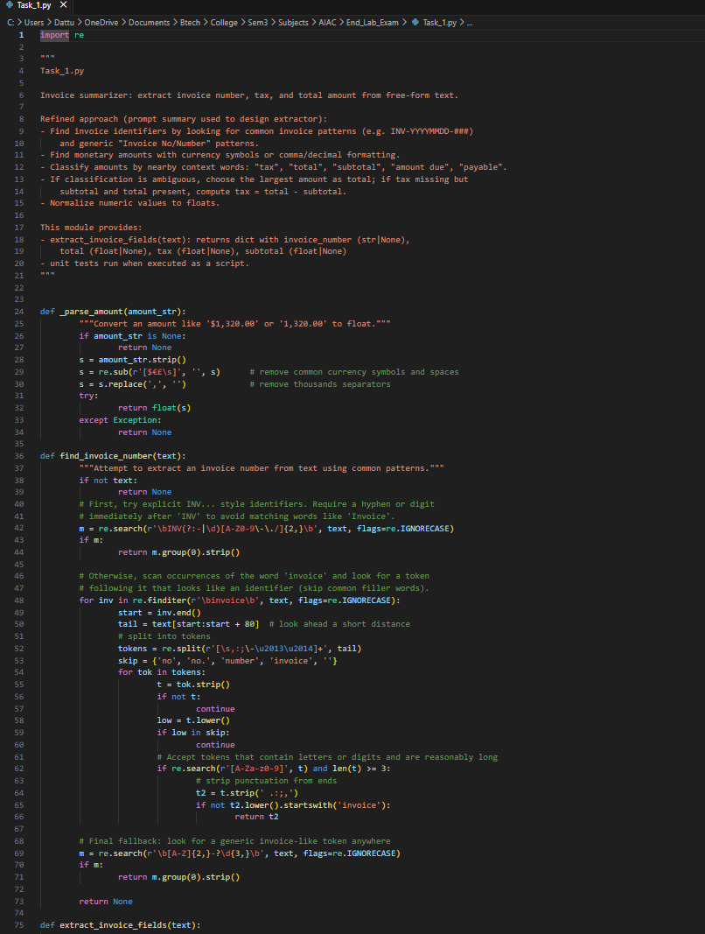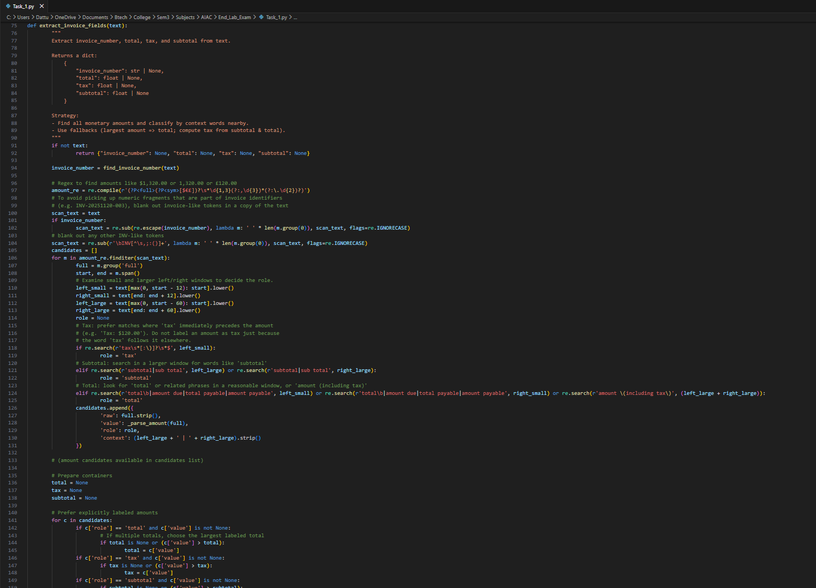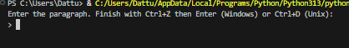
Q2. DB/SQL Scenario 2 — Online Course Enrollment System
An e-learning platform needs a backend database for course registrations.
Task
With AI assistance:
- Create tables for:
  - Students
  - Courses
  - Enrollments
- Write SQL queries to:
  - Enroll a student in a course
  - Generate a list of students enrolled in a specific course
  - Count total enrollments per course
- Provide schema documentation, inline comments, and test cases using sample entries.

